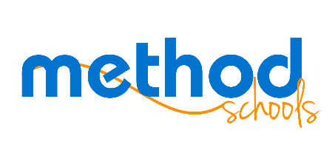

Board Meeting Agenda
June 25, 2015

Date: June 25, 2015
Time: 6:30 pm
Location: Method Schools-
2535 Camino del Rio S
San Diego, CA
92108
Remote participants:
732-432-1212
Meeting number:
883-383-017
Chair: 3975

Information Items
- Marketing update
- Staffing update
- Product update
- Final Budget report 2014-2015 & 2015-2016 final to be provided in July

Action Items
- LCAP
- Compass Learning Quote
- Course Outline- Junior & Senior Seminar

Next Meeting
- July 22, 2015

