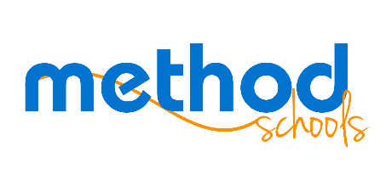

Board Meeting Agenda
Dec. 7, 2016
Murrieta, CA
6:00 pm

Call in info:

712-432-1212
Meeting ID: 883-383-017
Host: 3975
Information Items
- Marketing update
- Staffing update
- Product update
- Financial report
- One-time Bonus

Action Items
- Method Schools Board Policy BP 9.1- Repeating Courses

Next Steps
- Next board meeting- 3/8/17

