Method Schools Board Policy 6160

Tiered Reengagement Policy

For all pupils who are not generating attendance for more than three schooldays or 60 percent of the instructional days in a school week, or who are in violation of the written agreement, the following tiered reengagement policy will be enacted:

Stage One: Verification of current contact information for each enrolled pupil. AND Notification to parents or guardians of lack of participation within one school day of the absence or lack of participation.
Stage Two: A parent-teacher conference with the teacher of record will be scheduled to determine pupil needs, including connection with health and social services as necessary.
Stage Three: An SST (to include parent, pupil, teacher of record, and student success manager) will be held to review a pupil’s written agreement and reconsider the independent study program’s impact on the pupil’s achievement and well-being, consistent with the evaluation for satisfactory progress as defined by the board policy.
*The SST means a meeting involving, at a minimum, all parties who signed the pupil’s written independent study agreement.
Stage Four: Options for local in-person instruction will be provided to the student-pupil-learning coach. Students will be withdrawn from Method Schools five days from the Stage Four meeting.

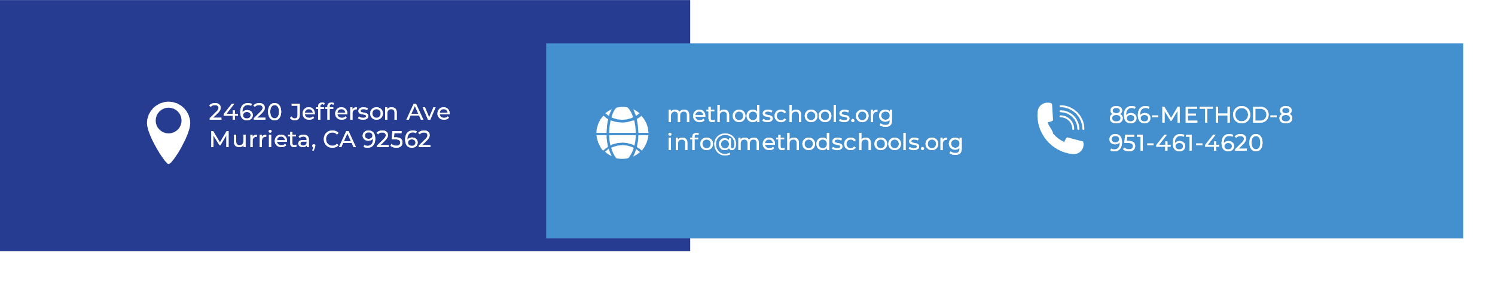
Board Approval Date: 8/10/2021

