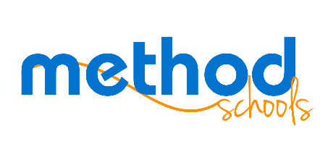

Board Meeting Agenda
Sept. 28, 2016
Murrieta, CA
6:00 pm

Call in info:

(916) 437-7282
access: 529

Information Items
- General update

Action Items
CLOSED SESSION: CONFERENCE WITH LEGAL COUNSEL – EXISTING LITIGATION
(Paragraph (1) of subdivision (d) of Section 54956.9)

Name of Case: San Diego Unified School District, Case No. 37-2015-00033720-CU-WM-CTL.

